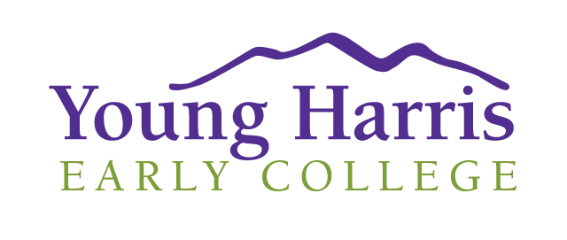
Welcome to Young Harris Early College! We are glad you have chosen to jumpstart your college education through Young Harris.

Course Options:
- Online classes – we offer 8-week online classes in most of the CORE subjects throughout the year. Online students must have a computer with webcam and mic and reliable access to the internet.
- Face-to-face classes at Habersham High School – we offer 4 courses in the Fall and 4 in the Spring right at the high school. Some of these will have the teacher in the room and some will be broadcast from our campus.

Proposed schedule of YHC classes at Habersham Central for 2018-19 school year:

Fall
Time | Course | Title | Instructor | Book type
1st block MW | COMM 1100 | Public Speaking | Dick Stafford | Brytewave book – ‘Introduction to the Speechmaking Process’
3rd block MW | ENGL 1101 | Composition I | Holly Burcham
4th block MW | ECON 1000 | Fundamentals of Economics | Mishal Ahmed | Physical book-  ‘Common Sense Economics’
4th block TR | POLI 1100 | American Government | Arch Kielly | Physical book – ‘The Basics of American Government’

Spring
Time | Course | Title | Instructor | Book
1st block MW | PSYC 1102 | Intro to Psychology | John Hummel | Brytewave book – ‘Psychology: Themes and Variations’
3rd block MW | ENGL 1102 | Composition and Literature | Holly Burcham
4th block MW | HIST 2111 | US History to 1865 | In process
?? (depends on interest) | ENGL 1101 | Composition I | Holly Burcham

Steps to enroll:
- Talk to your counselor about your interest
- Submit your application at http://discover.yhc.edu/applynow/inquiryform and choose ‘move on when ready’ as your student type. If you have questions, call Zach Chamberlin at (706) 379-5234.
- Submit an official copy of your high school transcript with your most recent grades.
- Submit your official SAT or ACT scores. If you have not yet taken these, you may be eligible if you have a 3.2 GPA as calculated by YHC.
- You will be contacted about your acceptance. Your acceptance letter will contain your login information and new YHC email address.
- Submit a Student Participation Agreement (SPA) available from your counselor. This will list the courses you want to take and will require a signature from the counselor, the student, and the parent.
*Steps 5 and 6 might be reversed, depending on timing.
- Complete your Dual Enrollment funding application at GAfutures. You must do this every semester for every college that you take dual enrollment classes with. http://discover.yhc.edu/applynow/inquiryform
- Complete the 2018-19 Moodle Orientation for Young Harris Distance Learning at http://moodle.yhc.edu.

Important Links:
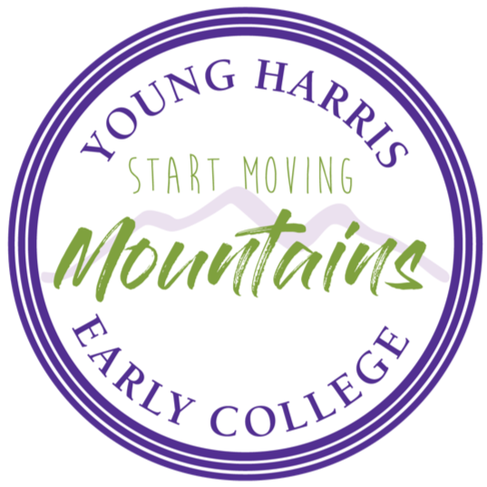
- Email: http://email.yhc.edu/
- Moodle: https://moodle.yhc.edu/ (Contains unofficial gradebook. You should be able to check your grades 24/7.)
- Self-Service: https://selfservice.yhc.edu/selfservice/Home.aspx (You can check your schedule here. This is also where the official midterm and final course grades are available.)
- Textbooks: online classes have digital textbooks. Most are available through Brytewave and that link is on your Moodle home page. Synchronous classes have physical textbooks that you will receive from your teacher. On-campus class books are available at the bookstore. YOU ARE RESPONSIBLE FOR MAINTAINING AND RETURNING ALL PHYSICAL BOOKS
- GAfutures: https://www.gafutures.org/ You MUST fill out an application each semester for each college that you take classes through in order for the State of GA to pay your tuition. Do this ASAP!
- Technical Help: send an email to helpdesk@yhc.edu.
- Procedures/Policy help: talk to your counselor or email dibauman@yhc.edu.

